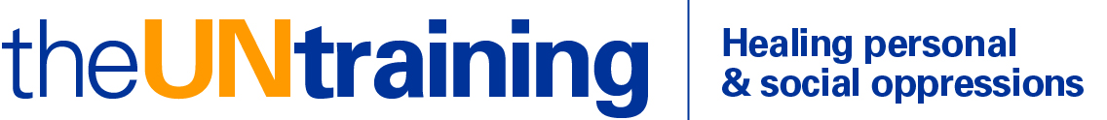

510-207-2377 www.untraining.org swan@untraining.org

Application for Untraining White Liberal Racism
Massachusetts, Phase 1, February-April 2018

Name: Email:

Address:

Phone(s):

Best times to call:

___ Yes, I have checked my calendar and I can commit to all six meetings:
Saturdays and Sundays 1-6pm: February 16 & 17, March 16 & 17, April 13 & 14

How did you hear about the program?

- What in your life is inspiring you to do the UNtraining at this time? Is there particular urgency for you, personally?

2) Briefly, how and where do you encounter issues of race in your life?

3) Have you done any anti-racism work before? If so, what kinds of programs?

4) What is your ethnic background? (e.g., English and Italian, Russian Jewish, etc.)

5) Is there anything else in your background, identities, or experience you would like us to know?

Email application as a Word document to swan@untraining.org by January 15, 2019. Thank you.

